

American International University-Bangladesh (AIUB)

**Department of Computer Science**

**Faculty of Science &Technology (FST) Spring 2020-2021**

**CSC 2210 Object Oriented Analysis and Design (OOAD)**

**Section: B**

**Group No: 3**

Online Shopping Management System

An Object-Oriented Analysis and Design (OOAD) project submitted By

|  |  |  |  |
| --- | --- | --- | --- |
| SL No | Student Name | Student ID | Contribution |
| 01 | **MD MAHAFUJ ANAM KHAN OVE** | **20-42238-1** | 20% |
| 02 | **SUBRATA DAS** | **19-40015-1** | 20% |
| 03 | **GHOSH BARSHAN** | **19-41305-3** | 20% |
| 04 | **SHAOWN BARUA** | **19-40674-1** | 20% |
| 05 | **MUN SAHA** | **19-41696-3** | 20% |

**CHAPTER 1: PROBLEM DOMAIN**

# 1.1 Project Background Analysis

The main objective behind this project is to develop a web-oriented application which can provide an online shopping feature to the users. In other words, this project aimed at creating a virtual shop environment for users, in some handy format, which will be available to them through internet. Although the idea of developing online shopping websites is not new in the electronic market and has been evolved soon after the World Wide Web (www). It is reasonable to say that the process of shopping on the web is becoming commonplace. The objective of this project is to develop a general-purpose e-commerce store where any product (such as books, CDs, food items computer mobile phones, electronic items, and home appliances) can be bought from the comfort of home through the internet. Customers can browse the catalog and select products of interest. User can login into ecommerce website, once he logged in then automatically one shopping cart will be created once user select an item for buy it will add to that cart. In case user thinks the selected item is not useful for him, then he can delete that item form the cart. More information will be needed to complete the transaction if customer want to buy item. Usually, the customer will be asked to fill or select a billing address, a shipping address, a shipping option, and select payment option. This system has been designed keeping in mind all the aspects such as loading the data complexity and maintaining the security of user credentials.

In current system user must go to shop and order products. It is difficult to identify the required product. Also, there are expenses for travelling from house to shop. It requires lots of time and time means a lot to everyone. Now people trying to make shopping system more easer by using online shopping system. Previously many works has been done on online shopping system but those are less user-&friendly because user interface is not user friendly. All are focused some special types of customer that’s why their interface is not user-friendly for all. Here my system ensure that every one can use this system more easily, we focused everyone, and interface is more user friendly for all. Here we focused on this problem and make a user-friendly interface for all, here is no need to special knowledge for buying anything. Customer can buy product easily

# 1.2 Project Solution and Feasibility Analysis

The software is said to have life cycle composed of several phases. At the feasibility stage, it is desirable that two or three different configurations will be pursed that satisfy the key technical requirement but which represent different level of ambition and cost. Feasibility is the determination of whether or not a project is wo (h doing. A feasibility study is carried out select a best system that mates performance requirements. The data collected during primary investigation examines system feasibilities that is likelihood that the system will be beneficial to the organization. Four tests for feasibility study are as follows: -

**Technical Feasibility**: This is concerned with specifying equipment and software thar will successfully satisfy & the use considerably, but might include

* The feasibility to produce output in a given time because system is fast enough to handle multiple users.
* Response time under certain circumstances and ability to process a certain volume of transaction of a particular speed.
* Feasibility to communicate data to distant location. All this are successfully fulfilling this project.

**Economic Feasibility**: Economically this system is feasible.

**Operational Feasibility**: It is mainly related to human organizational as social aspects. The points to be considered are - this system interface is standard, user friendly and provides extensive help. Hence no special training is not required. Social Feasibility: Social feasibility is determination of whether a proposed project will be acceptable to people or not, so this project is totally Social and Feasible.

**What makes this project new, innovative, interesting, or otherwise distinct from other similar projects?**

1. The present scenario for shopping is to visit the shops arid market manually and then from the available product list one needs to choose the item he or she wants and then payment for the same item mainly in cash mode is done, as not every society is well educated and aware to use net banking or card modes or wallets etc. This system is not much user friendly as one needs to go to the market physically and then select items only &om the available list. So mostly it is difficult to get the product as per our desire. Description about the products is less available and are mostly verbal only. For this type of shopping, one needs to have ample amount of free time. Also, not really good markets exist everywhere, so many times good markets become out of reach for certain people. This existing system of buying goods has several disadvantages. It requires lots of time to travel to the particular shop to buy the goods. It is having lots of mental work. Since everyone is leading busy life now a days, time means a lot to everyone. Also, there are expenses for travelling from house to shop. It is less user-friendly. In current system user must go to shop and order products. It is difficult to identify the required product. More over the shop from where we would like to buy something may not be open 24*? *365. Hence, we have to adjust our time with the shopkeeper's time or vendor's time. In current system user have to go shop to view the descriptions the product.

1. The proposed system helps in building a website to buy, sell products or goods online using internet connection. Unlike traditional commerce that is carried out physically with effort of a person to go and get products, our project will make it easier for human to reduce physical work and to save time. The basic concept of the application is to allow the customer to shop virtually using the Internet and allow customers to buy the items of their desire from the store. In this proposed system customers need not to go to the shops for purchasing the products.

Customer can order the product he/she wishes to buy through the use of this system. The shop owner can be the admin of the system. Shop owner can appoint officials particular$ to handle this, who will help owner in managing the customers and product orders. The system also endorses a home delivery system for delivering the purchased products. Enables customers to shop or do other transactions 24 hours a day, all year round from almost any location. It can be accessed over the internet. Purchasing of goods online, user earn chose different products based on categories online payments, delivery services and hence covering the disadvantages of the existing system and making the buying easier and helping the vendors to reach wider market. It provides consumers with more choices. Customer can purchase products online,

A good ecommerce site full fill the following factors.

* Knowing when an item was saved or not saved in the shopping cart.
* Retuning to different parts of the site after adding an item to the shopping cart.
* Easy scanning and selecting items in a list.
* Effective categorical organization of products.
* Simple navigation from home page to information and order links for specific products.
* Obvious shopping links or buttons.
* Minimal and effective security notifications or messages.
* Consistent layout of product information.
* Admin has the authority to add new particulars to the items list whenever needed.
* Permission to administrator to remove items, anytime.
* Allows the admin to modify the price of each item, whenever required or felt like.
* Admin has the authority to update the description of each item.
* Permission to the admin to view information about each customer who checkouts the items list.

**3.** The main advantage of this system over traditional commerce is the user can browse online shops, compare prices and order products sitting at home on their PC, laptop, mobile. Secure

profile management facilities for customers. Shopping cart feature allows online shopping customers to "place" items in the cart. It decreases the cost of creating, processing, distributing, storing and retrieving paper-based information. Expands the marketplace to national and international markets. Upon "checkout' the software calculates as total for the order including shipping anil handling postage, packing and taxes, if applicable. Reduces the time between the outlay of capital and the receipt of products and services.

**CHAPTER 2: UML DIAGRAM**

# 2.1 Use Case Diagram

In an Online Shopping management system, there are several types of users. In this system, user can view products and search products. User can also get registered and create an account. A registered customer need to login to the system before they use this system. But to login customer have to go through password verification. System Administrator deals with the account of the customers. In this System, An Administrator manage inventory and confirm delivery . After login System customer can Manage their shopping chart by add products to chart and delete products from chart if he/she needed. A customer can pay his bills in online. System Customer can pay bills by credit cards or debit cards. The payment service provider deals with the payment of the customer.

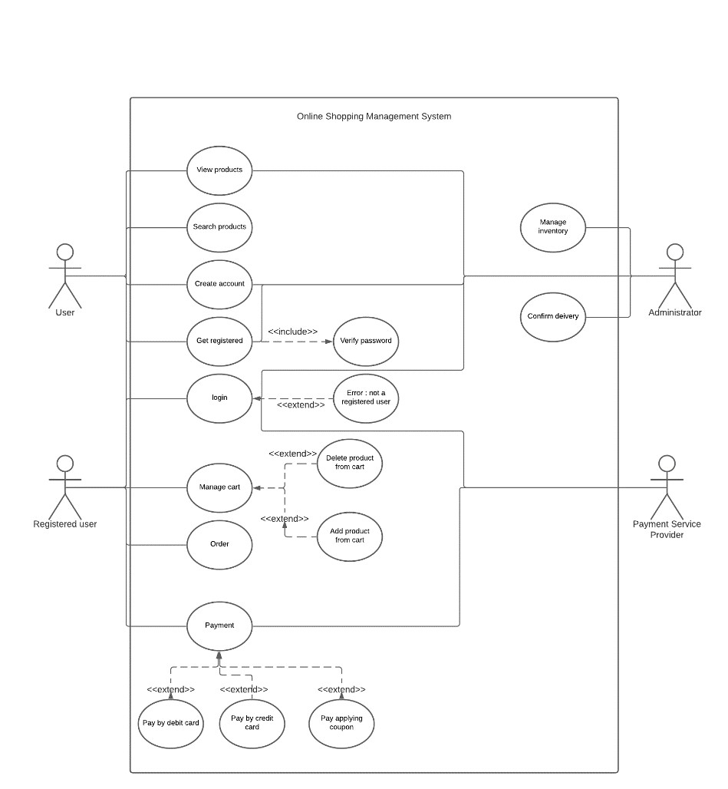

# 2.2 Class Diagram

In a online shopping system a customer has six attributes customerName, customerID, address, email, customerMobile, customerAccountNo. All attributes are private and all the attributes are string type. there are five methods in customer class. A customer may have one account and a customer has one shopping cart. A customer has many products in shopping cart. Customer can make payment through credit and debit card. In the Order class there are five attributes:orderId, orderDate, orderItems, totalAmount, deliveryAddress. Except totalAmount all the attributes are string. totalAmount is double. there are five methods in order class. an order has one payment. in the Product class there are fourattributes:productName, productId, productDescription, productPrice. except productPrice all of them are String type. productPrice is double. there are six Methods in product class. Administrator manage many inventories and maintain many customers.

**Design (name, attributes, operation) of 3 classes**

|  |  |  |  |  |
| --- | --- | --- | --- | --- |
|  | Customer | | |  |
| -customerName: string  -customerid: string  -address; string  -email: string  -customerMobile: string  -customerAccountNo; string | | |
| +setCustomerName (name: String)  +getCustomerId (): String  +getCustomerAddress (): String  +getMobileNo : Integer  +getAccountNo (): String | | |
| Order | |  | Product | |
| -orderId: string  -orderDate: string  -orderitems: string  -totalAmount: double  -deliveryAddress: string | |
| -productName: string  -productID: string  -productDescrition: string  -productPrice: double | |
| +setProductName (name: String)  +getProductId (): String  +setProductDescription  (description: String)  +getProductDescription ():  String  +setProductPrice(price: Double)  +getProductPrice(): Double | |
| +setDeliveryAddress (): String  +setOrderItems (): String  +getOrderId (): string  +getOrderDate (): String  +getTotalAmount: Double | |
|  | |

**Class Diagram**

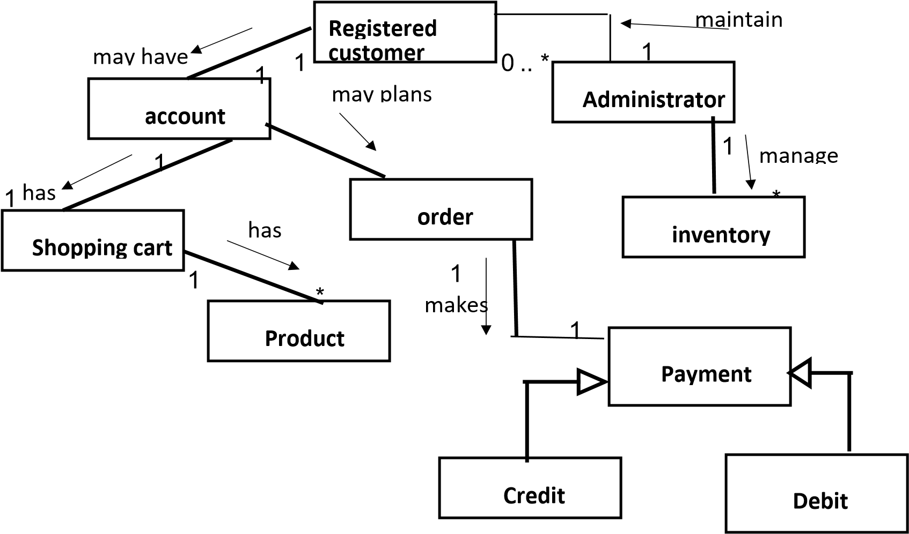

# 2.3 Sequence Diagram

In an Online shopping Management system user can create new customer account. For access in the account customer need to **login** to the system before they use this system. But to Login customer have to go through password verification. If the password is error, then it displays **login error**. The system verifies the customer authentication using the information provided in customer account. In case of unsuccessful verification customer authentication, the customer request is denied. After access in account, System user can **search** and **view** items. When customer view items they can **get description** and **get price** of the items **at the same time**. Customer can **Add item to shopping cart** in the system. The customer can place order in the system. The customer can **update** in the cart and get the update cart list. If the shopping cart is not updated then the customer get notification. The system can check availability of the items. If the items are available the system allow to order that item. If the item is not available Customer get notification. Then the customer can confirm the order and pay bill for the items. After paying bill **payment Information** is written in the database and the customer get the confirmation **at the same time.** If the Payment bill process is not done then Customer get notification again. An **unprocessed order** can get accepted or rejected by the system. If the order accepted by the system but some items are not available then the order **pending** on the system. But if all items are available then it can be considered as **fulfilled** order by the system. After successfully place first order the Customer considered as **active** Customer. If the customer does not place his first order, then back to initial state which is **Prospective**. If the customer missed the payment, Then the customer gets **Warning** by the system. If the customer not paid the payment even after warning, then the customer gets suspendered. If Customer paid the payment for the items, then the customer considered as **Preferred** customer.

**FOR PAYMENT FOR SHOPPING CART**

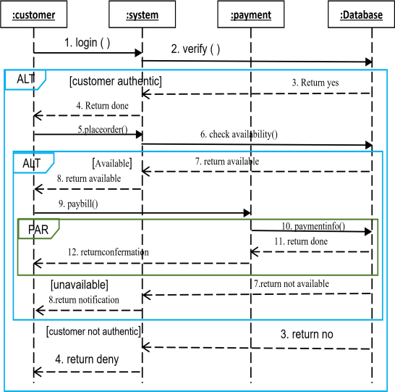 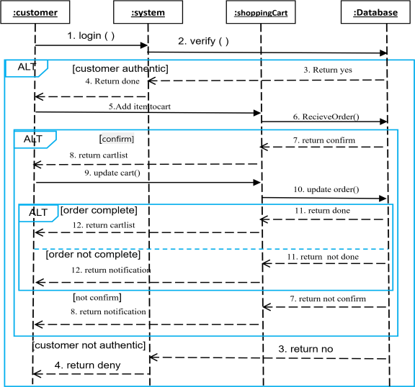

# 2.4 Statechart Diagram

In an online shopping system, when a product purchase order is issued the system will check if the item is available or not. If the order is rejected then the system will stop. If the order is accepted then the system will show order fulfilled. If some of the ordered products are not available then the system will show pending order. After confirming order, the system will ask for payment. If the payment is paid then the system will show preferred. If not, then the system will give warning. If the payment is not paid even after warning, then the system will suspend the order.

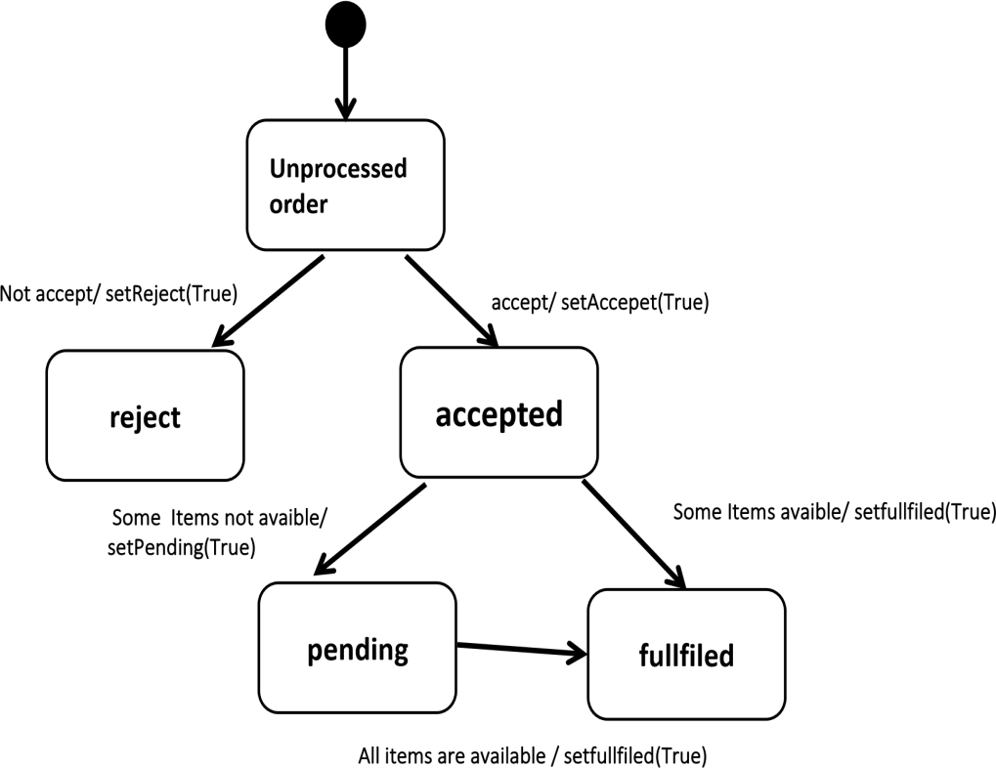

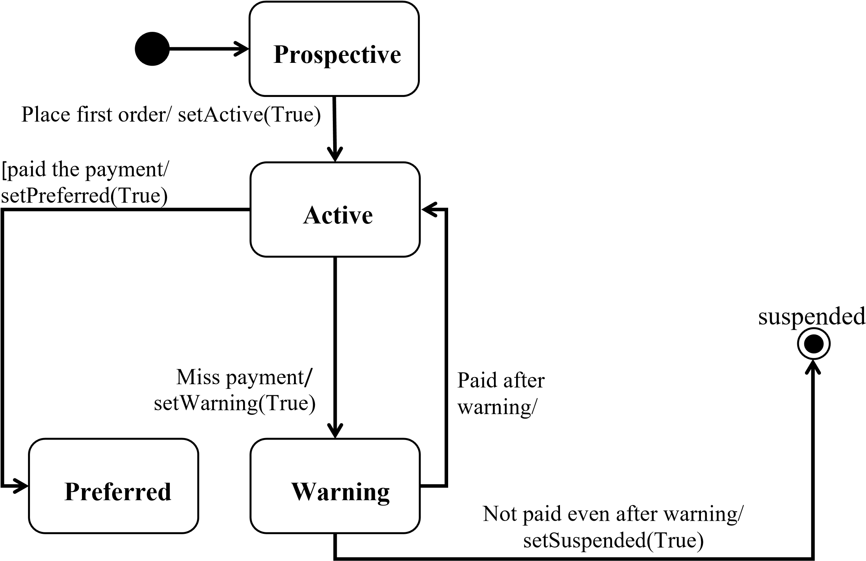

# 2.5 Activity Diagram

In an online shopping system, a customer login in their account by entering their pin. Then the system verifies the pin. If the pin is correct then a customer can access their account. And they can view item. Then the system will show the customer item description and price. Then a customer can order products. If the password is incorrect then the system will show login error and the system will end. In shopping cart, a customer, a search for items. If the item is found then they can view item. They can add products to their shopping cart. They can get the price of products. They can confirm order. If the price is paid then system will case order. If not, system will cancel order. If the item is not found system will take the back to search item.

**PAYMENT SHOPPING CART**

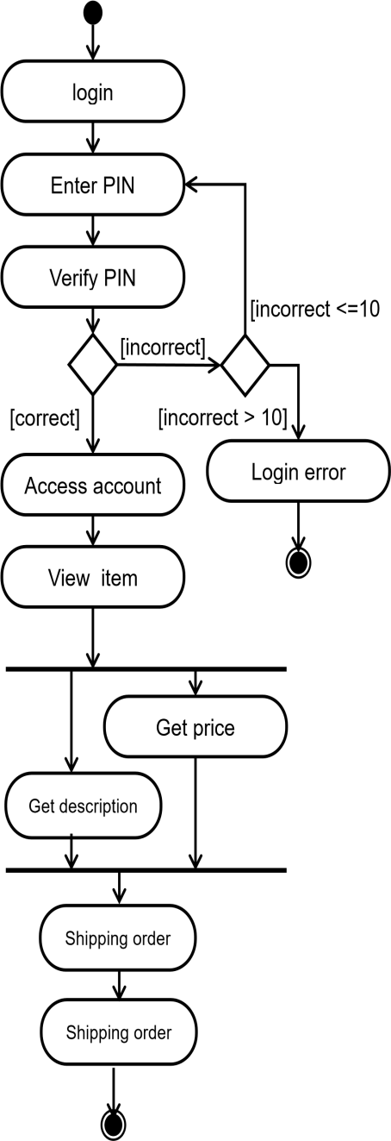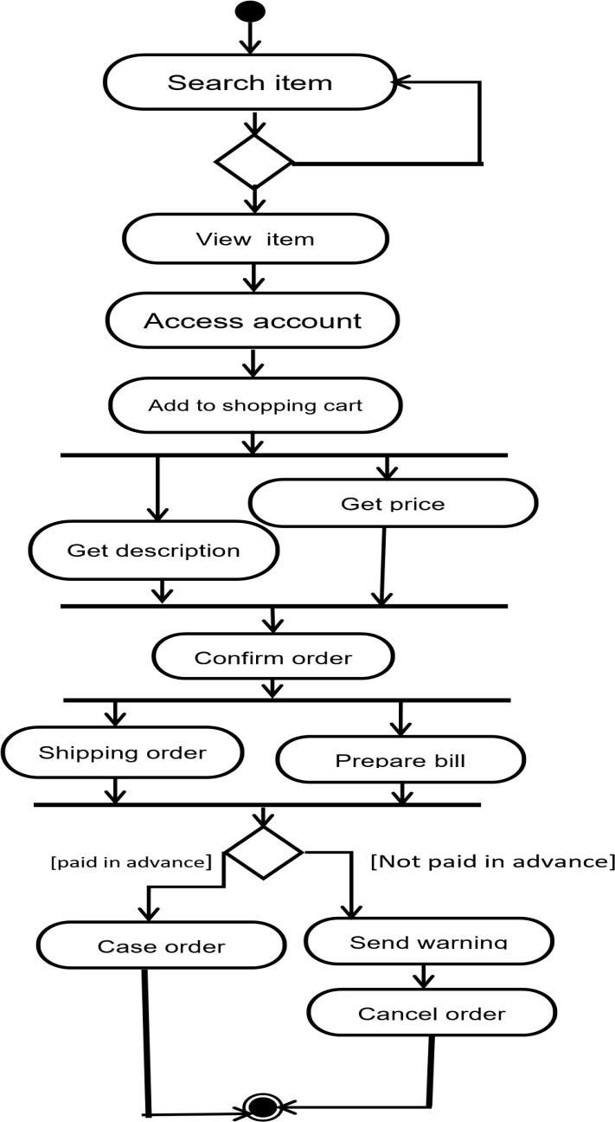

THE END

THANK YOU